**LASSI Scanner Characterization Tests**

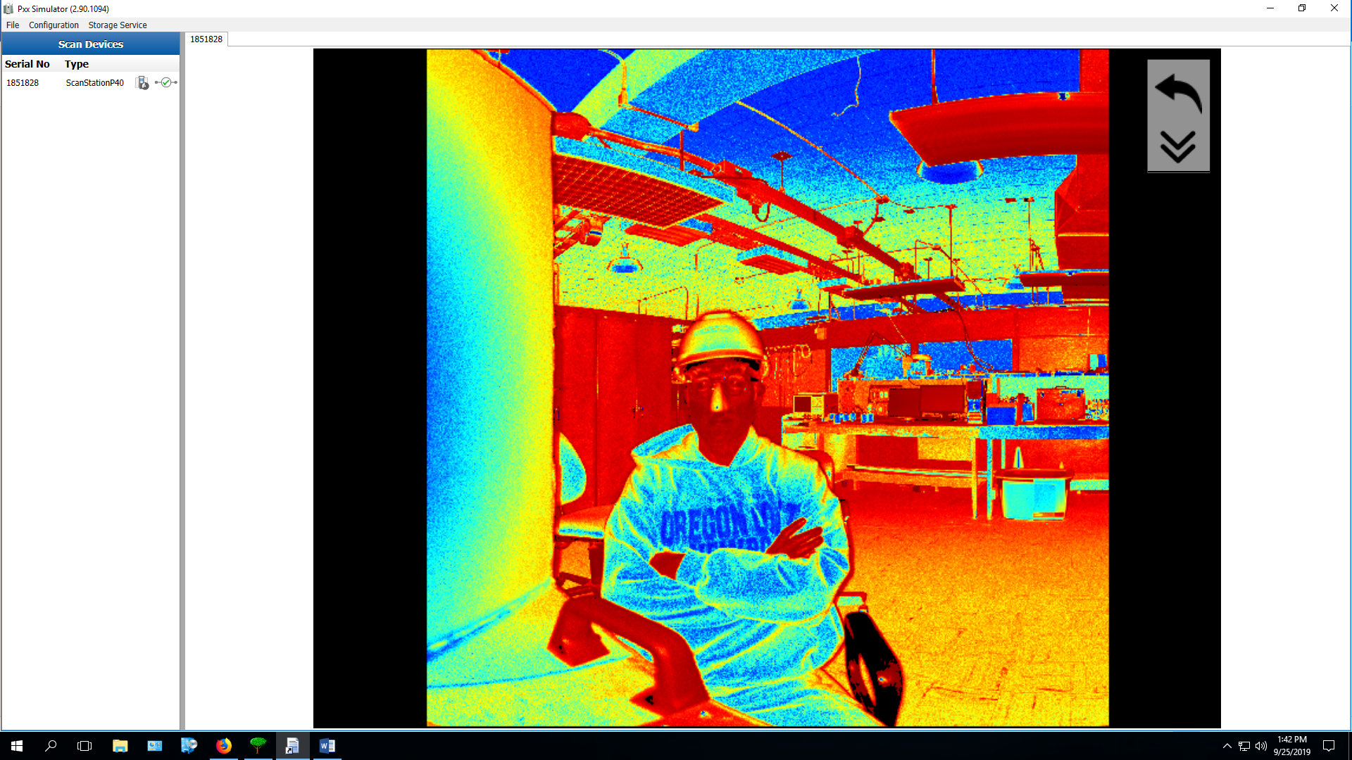

*OR, How I Learned To Stop Worrying and Love The Scanner*

**Lab Setup:**

The LASSI scanner has been mountend in the Jansky Lab on a piece of metal on a work bench. We connected the scanner directly to the PC, and ran scans using lassi-analysis’s testScanRange function.

Settings:

resolution = “[63mm@100m](mailto:63mm@100m)”

sensitivity = “Normal”

scan_mode = “Speed”

Project: testScanRange

Logs written to: /home/scratch/pmargani/LASSI/runTLSlogs

Scanner Data exported to: /home/sandboxes/pmargani/LASSI/data

We placed a large board near the scanner to use as a reference, since outside of the scanner’s own viewing software (see Appendix A), it can be difficult to distinguish objects in Paraview or Matplotlib.

**Scan Summary**

|  |  |  |  |  |  |  |  |  |  |  |
| --- | --- | --- | --- | --- | --- | --- | --- | --- | --- | --- |
| Scan | Cntr Az | Cntr El | Fov Az | Fov El | Sq. Deg. | Bytes PTX | Bytes CSV | Scan Mins. | Exp. Mins | Notes |
| 11 | 0 | 0 | 20 | 180 |  | 104924359 | 79317542 | 0.63 | 0.85 |  |
| 12 | 0 | 0 | 30 | 180 | 5400.00 | 156644750 | 118415703 | 0.70 | 1.06 |  |
| 13 | 0 | 0 | 45 | 180 | 8100.00 | 234322012 | 177136850 | 0.79 | 1.51 |  |
| 14 | 0 | 0 | 90 | 180 | 16200.00 | 467164052 | 353157534 | 1.06 | 2.88 |  |
| 15 | 0 | 0 | 180 | 180 | 32400.00 | 945220875 | 714607144 | 1.61 | 5.67 |  |
| 2 | 0 | 0 | 270 | 180 | 48600.00 | 1421581521 | 1077749455 | 1.62 | 8.23 |  |
| 18 | 0 | 0 | 360 | 180 | 64800.00 | 1900629947 | 1443012294 | 1.60 | 11.59 |  |
| 19 | 0 | 0 | 90 | 90 | 8100.00 | 234653128 | 177524009 | 1.08 | 1.62 |  |
| 20 | 0 | 45 | 90 | 90 | 8100.00 | 231532680 | 174472420 | 1.08 | 1.57 |  |
| 21 | 90 | 0 | 90 | 180 | 16200.00 | 465640503 | 352007053 | 1.04 | 2.96 |  |
| 22 | 180 | 0 | 90 | 180 | 16200.00 | 479295420 | 365414848 | 1.08 | 3.01 |  |
| 23 | 270 | 0 | 90 | 180 | 16200.00 | 479214741 | 365352826 | 1.08 | 2.97 |  |
| 24 | 90 | 0 | 90 | 90 | 8100.00 | 233056641 | 176363419 | 1.09 | 1.64 |  |

**Scan Details**

**Scan ?**

0 0 10 180

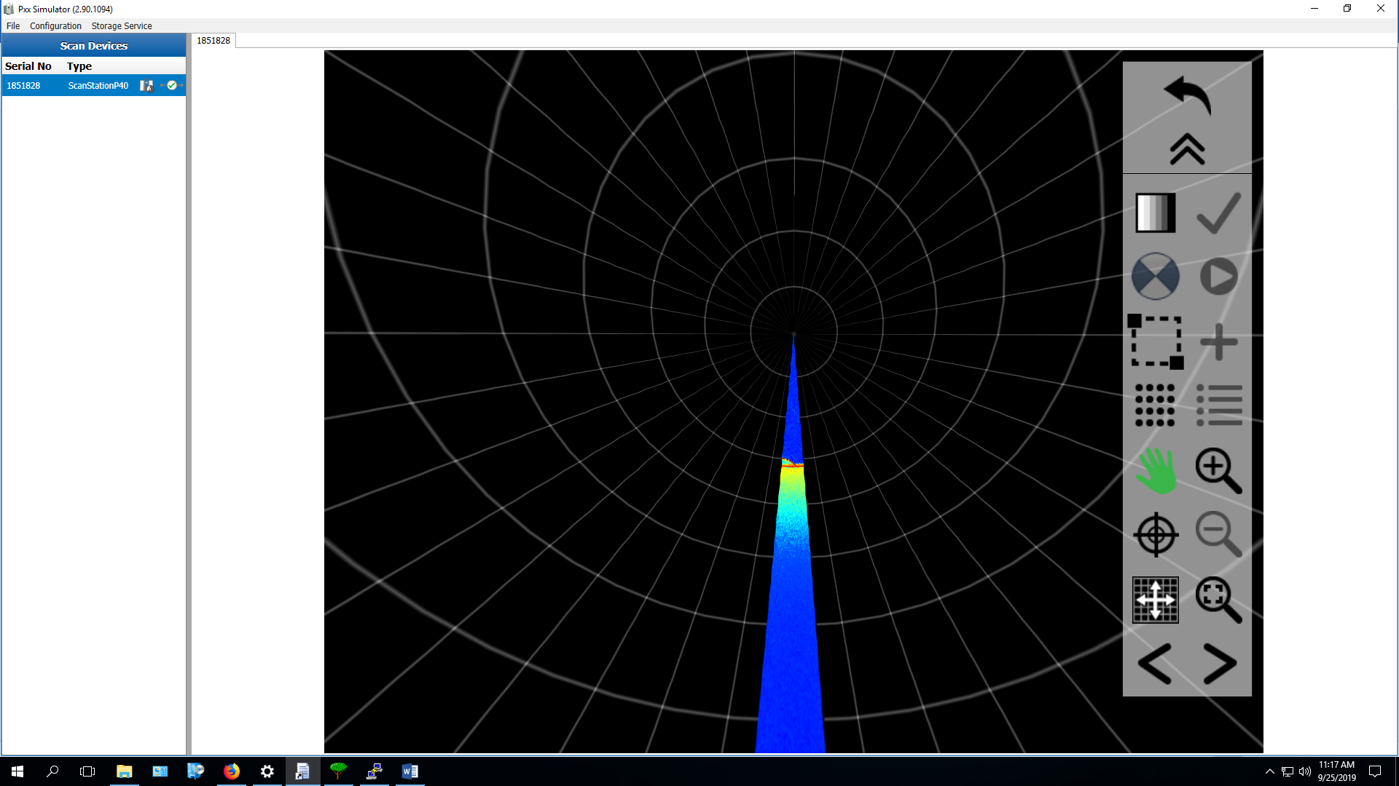

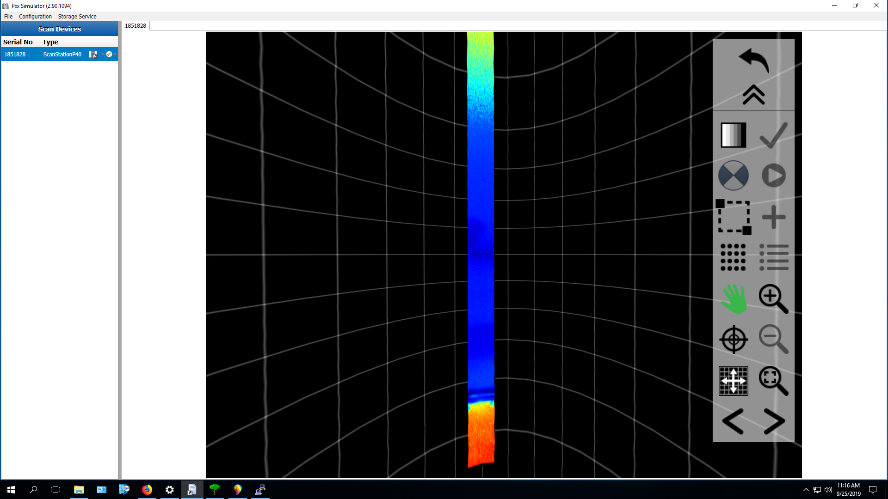

**Scan 11**

0 0 20 180

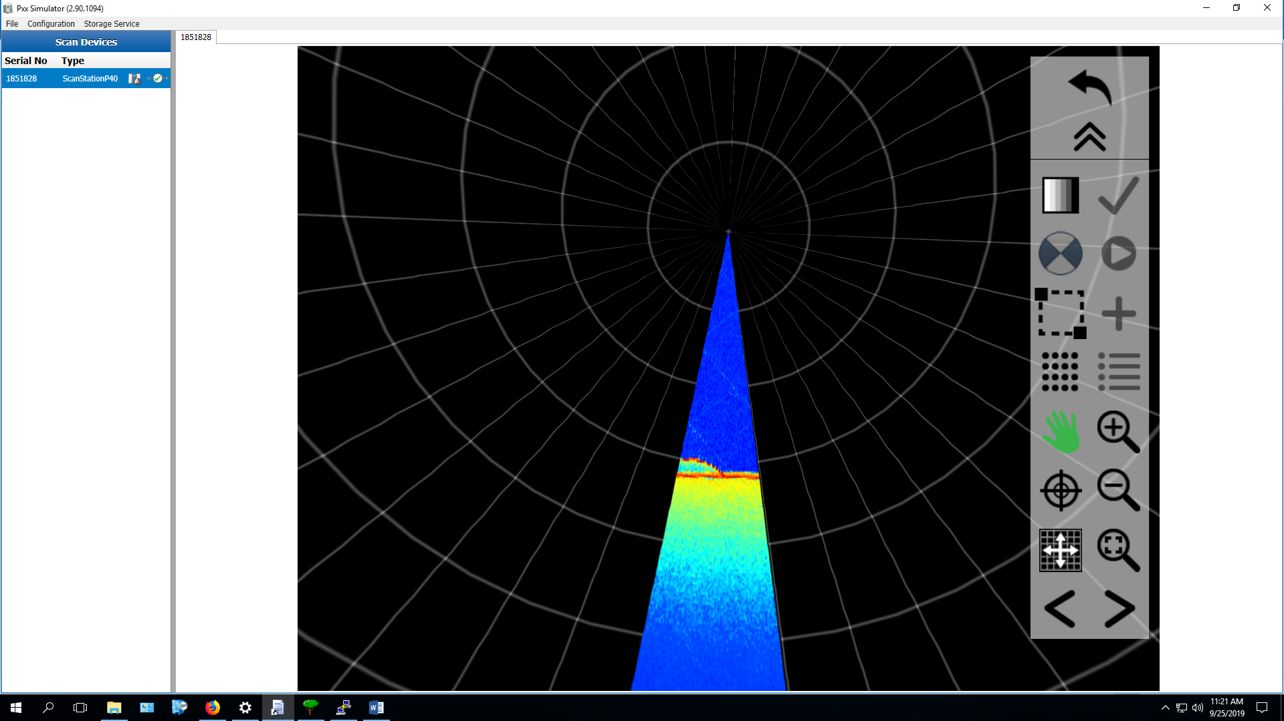

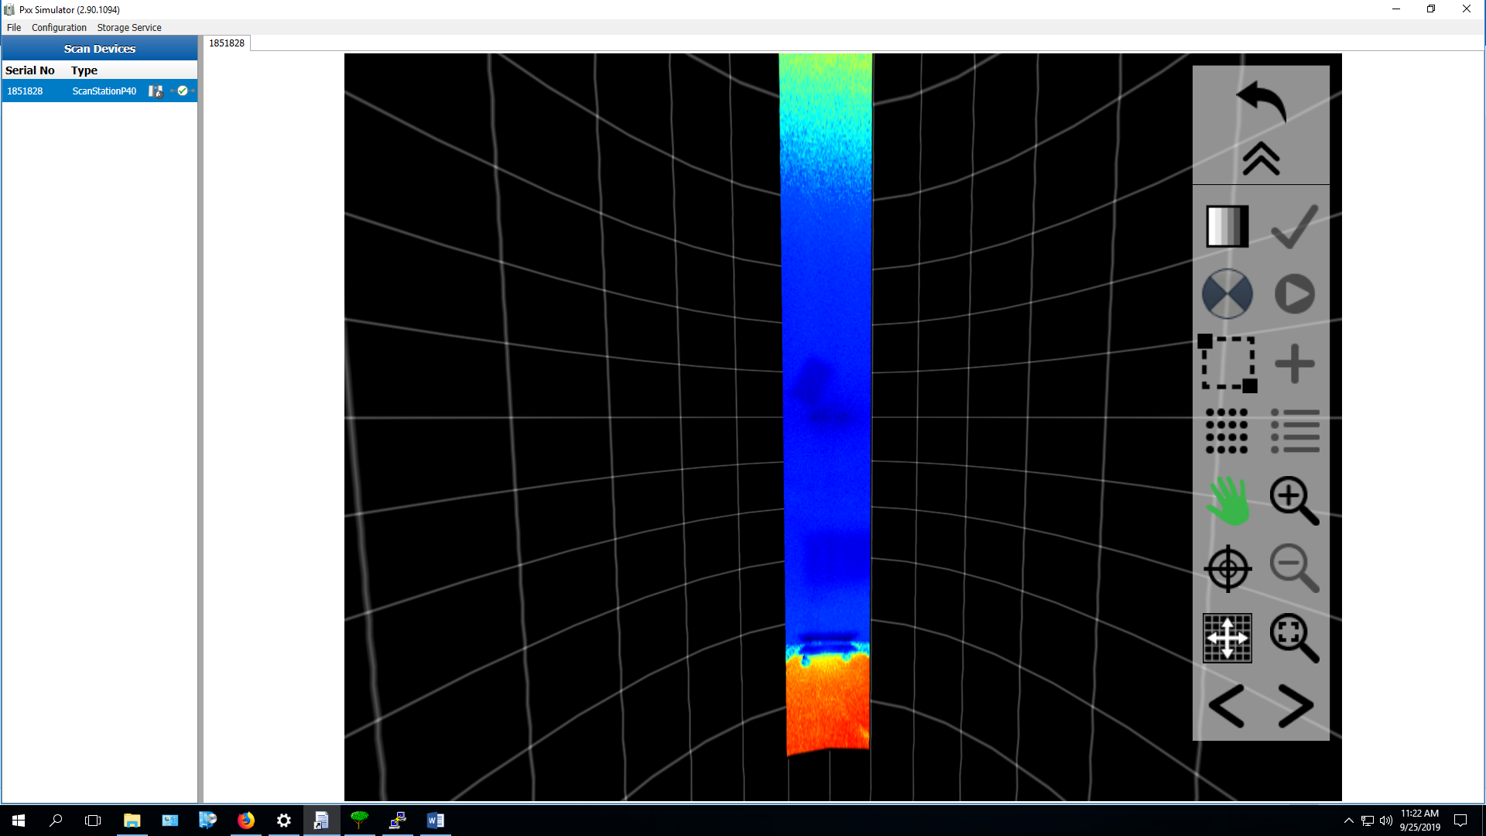

**Scan 12**

0 0 30 180

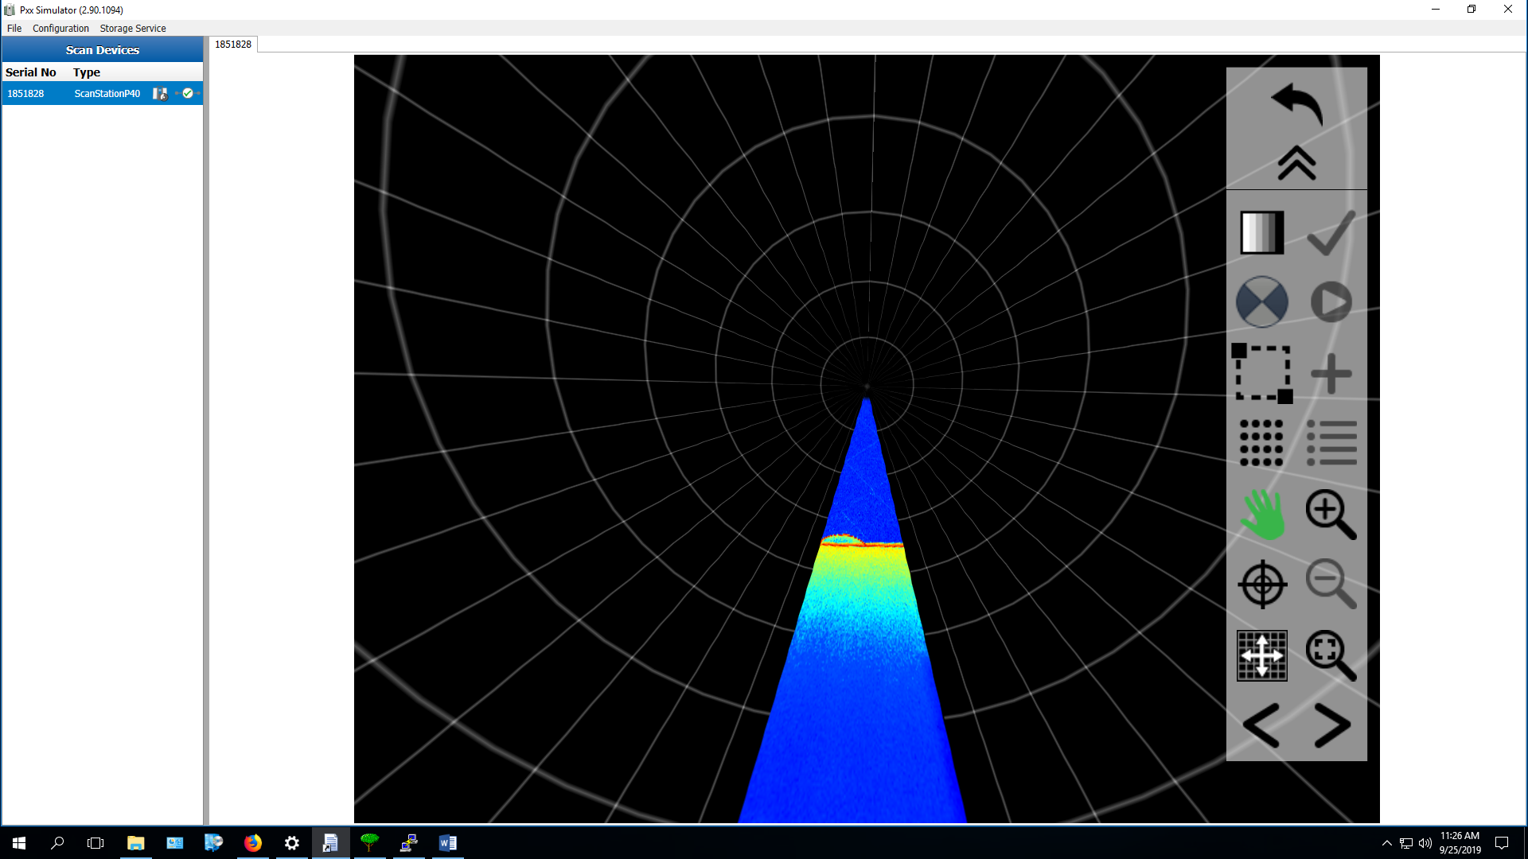

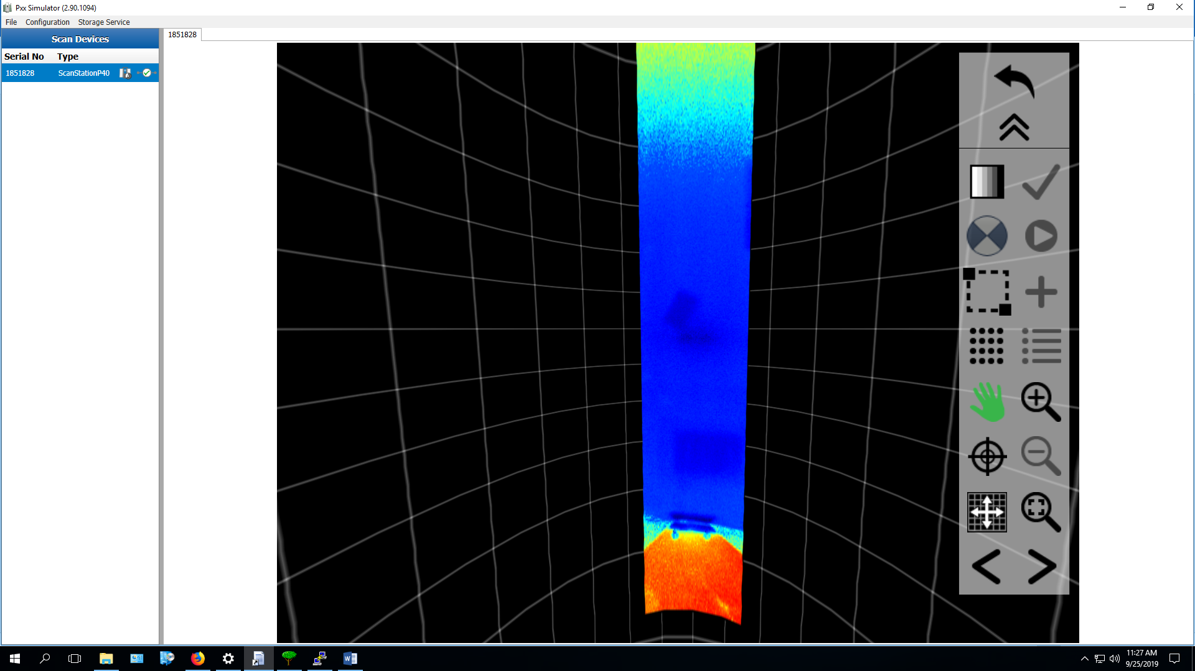

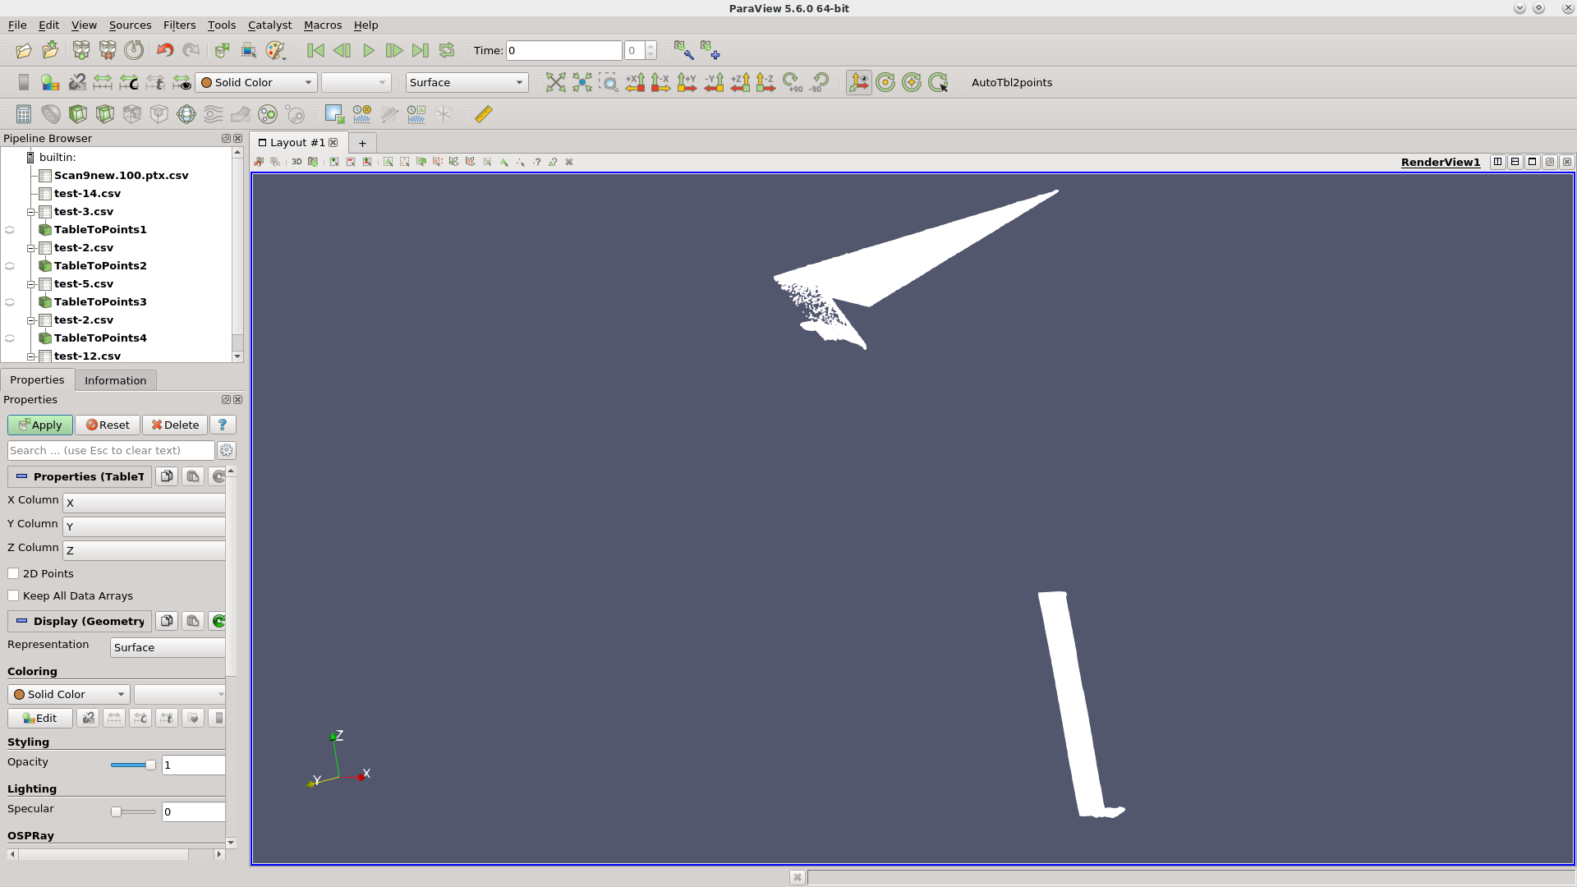

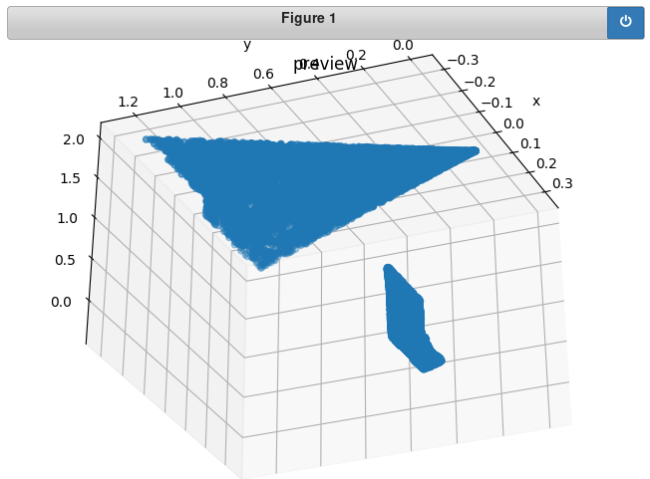

**Scan 13**

0 0 45 180

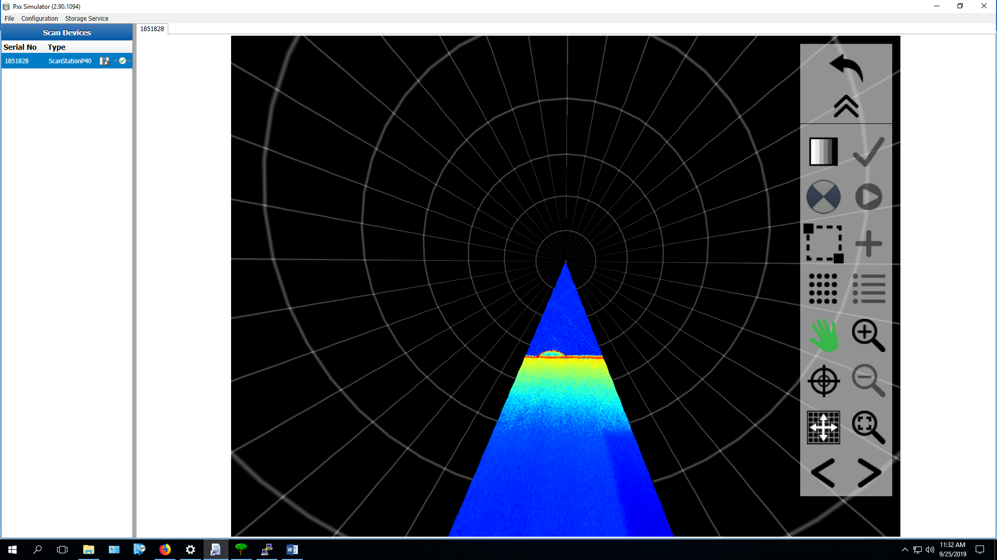

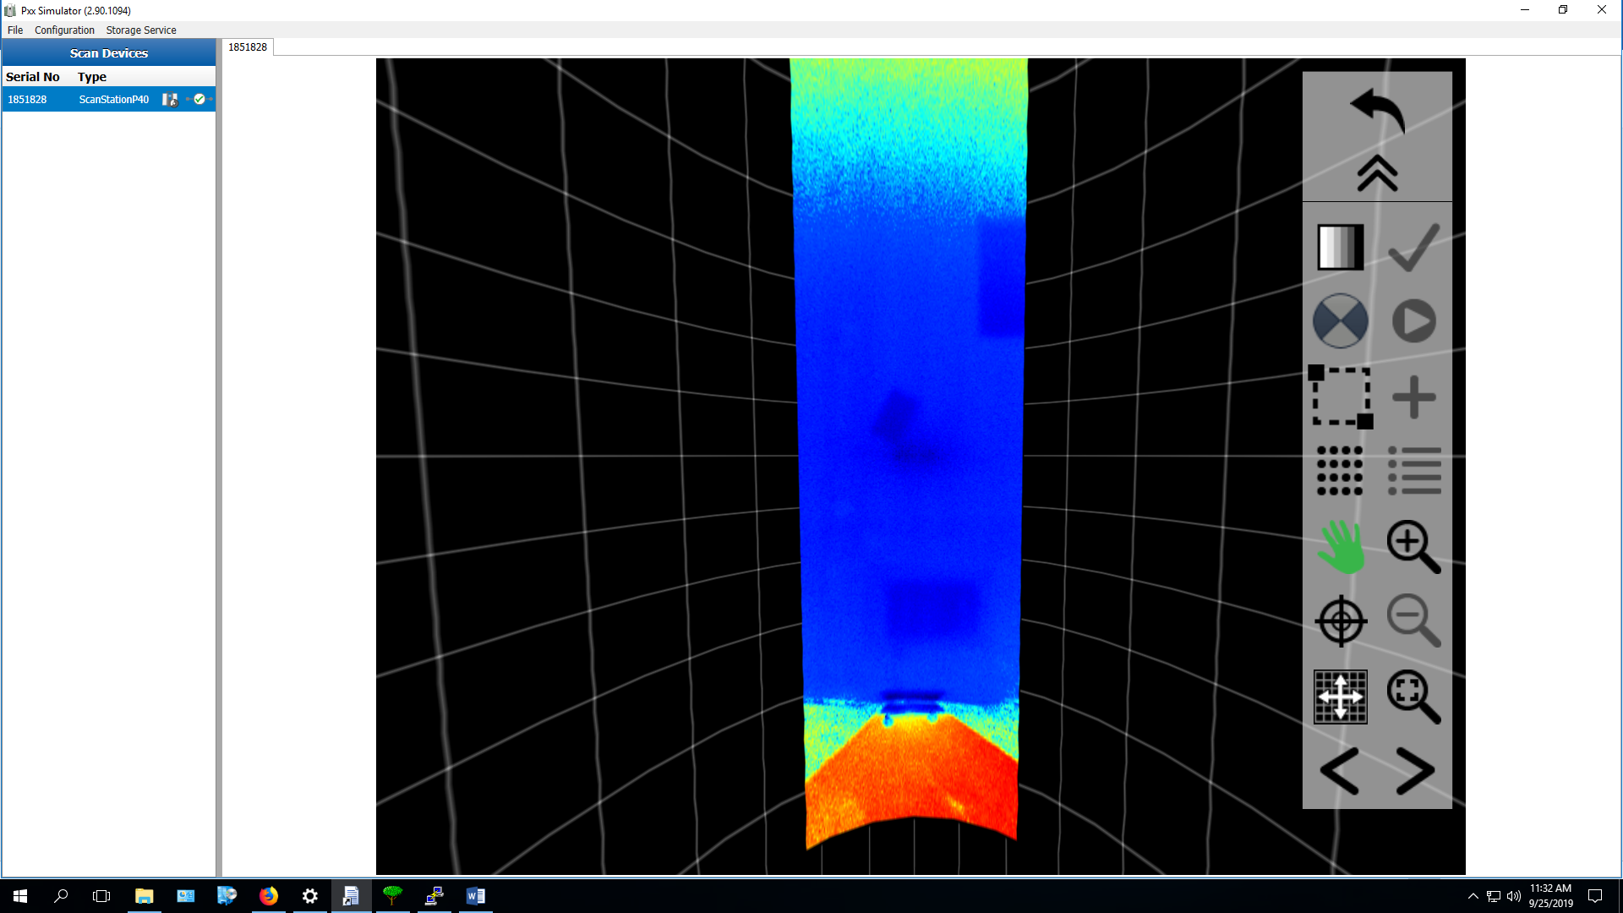

**Scan 14**

0 0 90 180

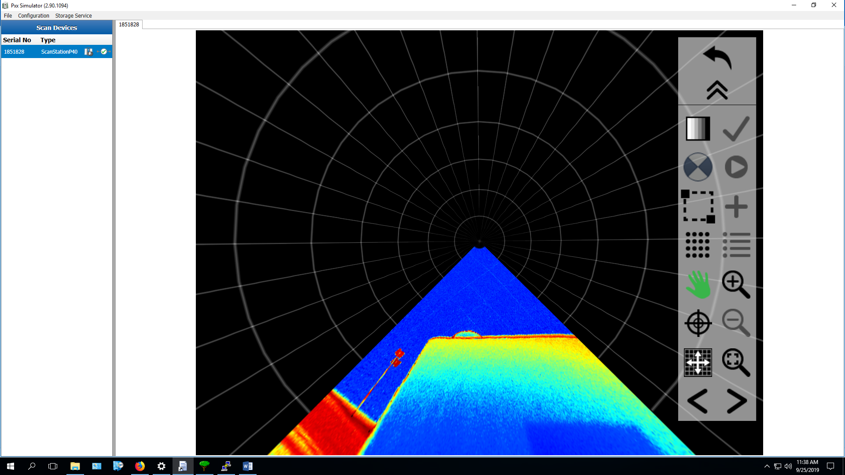

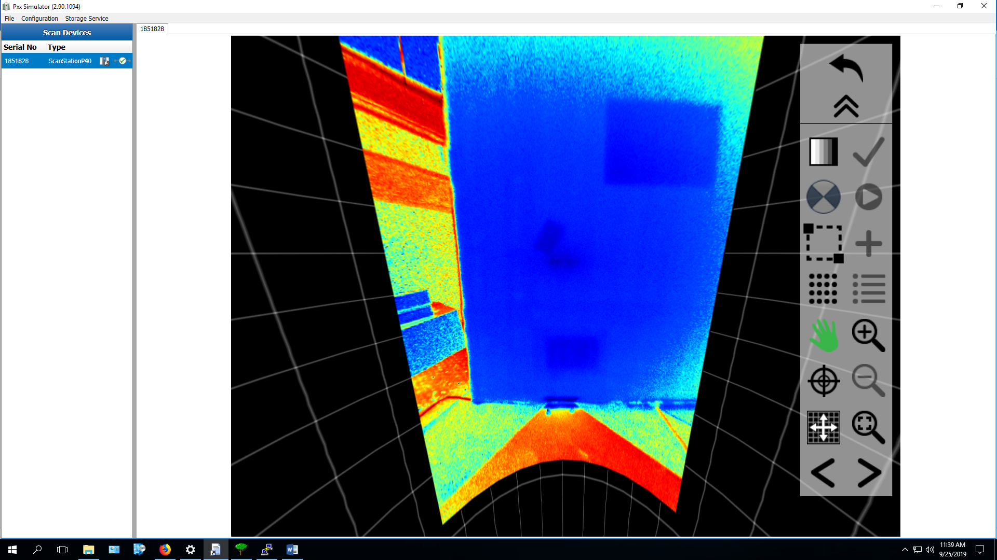

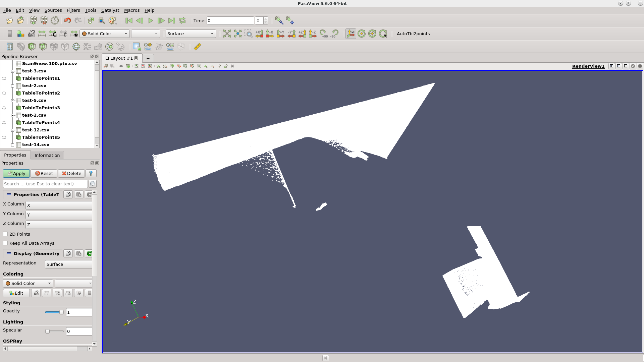

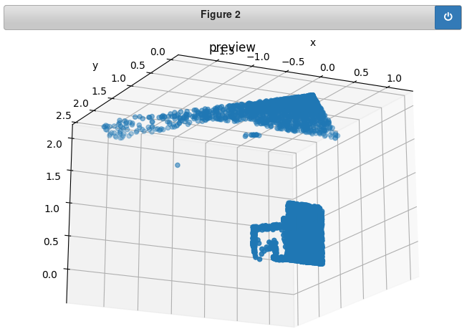Paraview and matplotlib offer equivalent 3D views of this data.

**Scan 15**

0 0 180 180

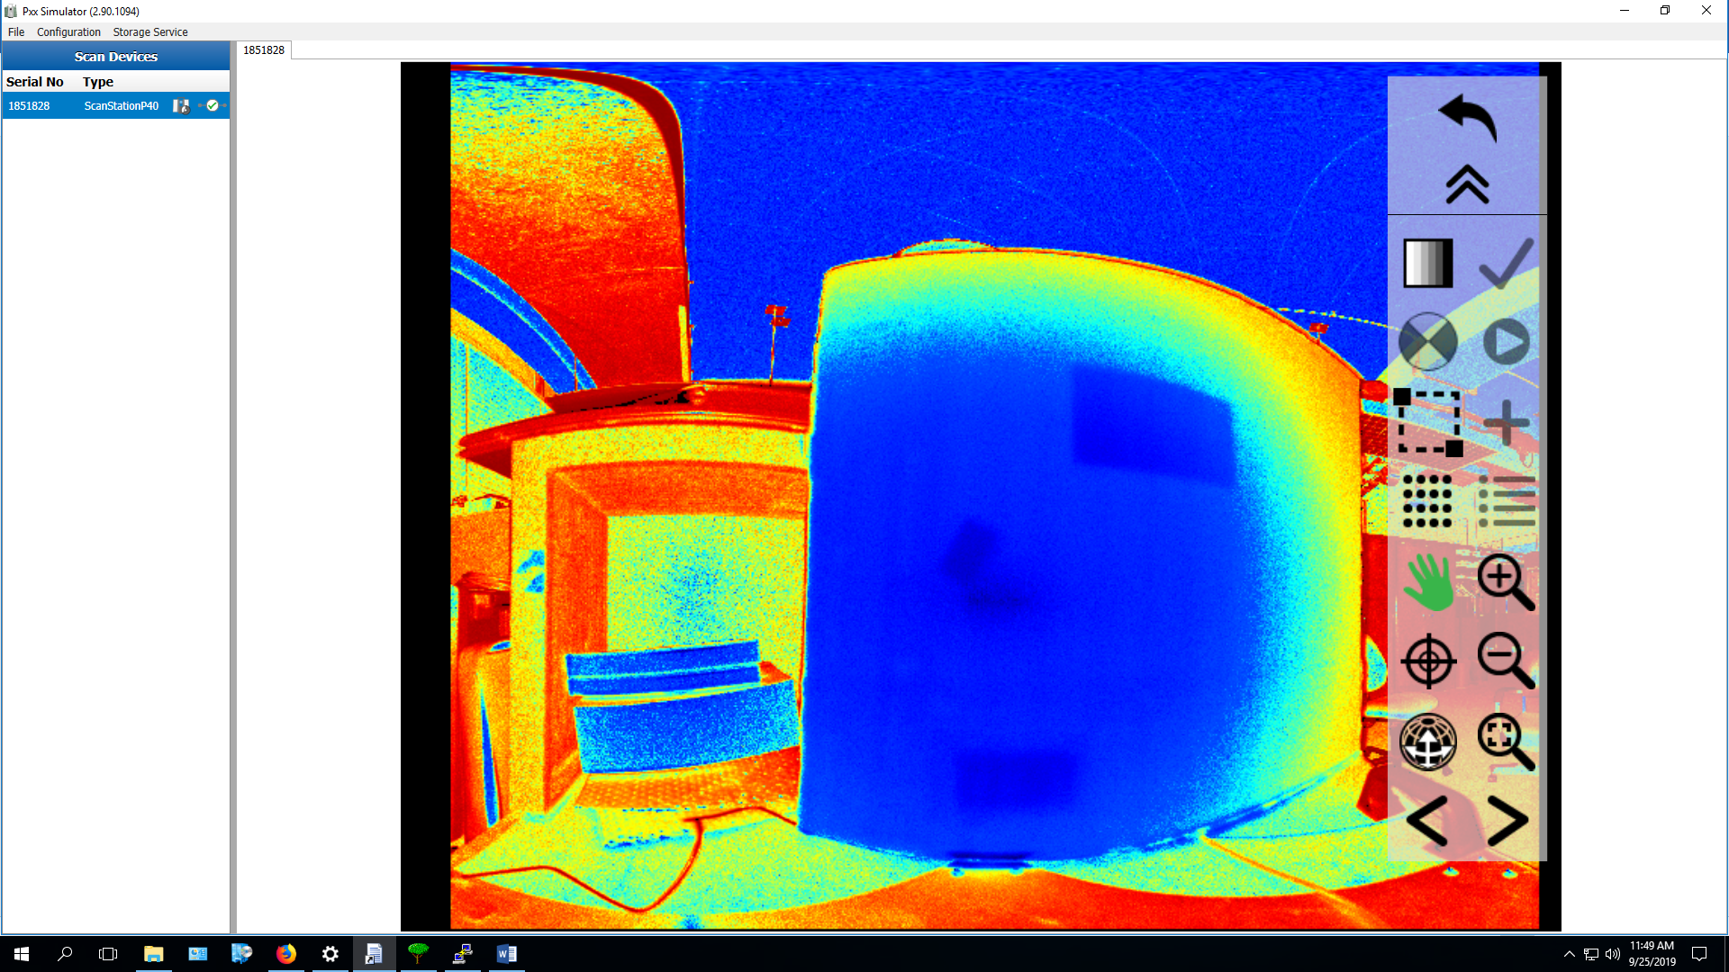

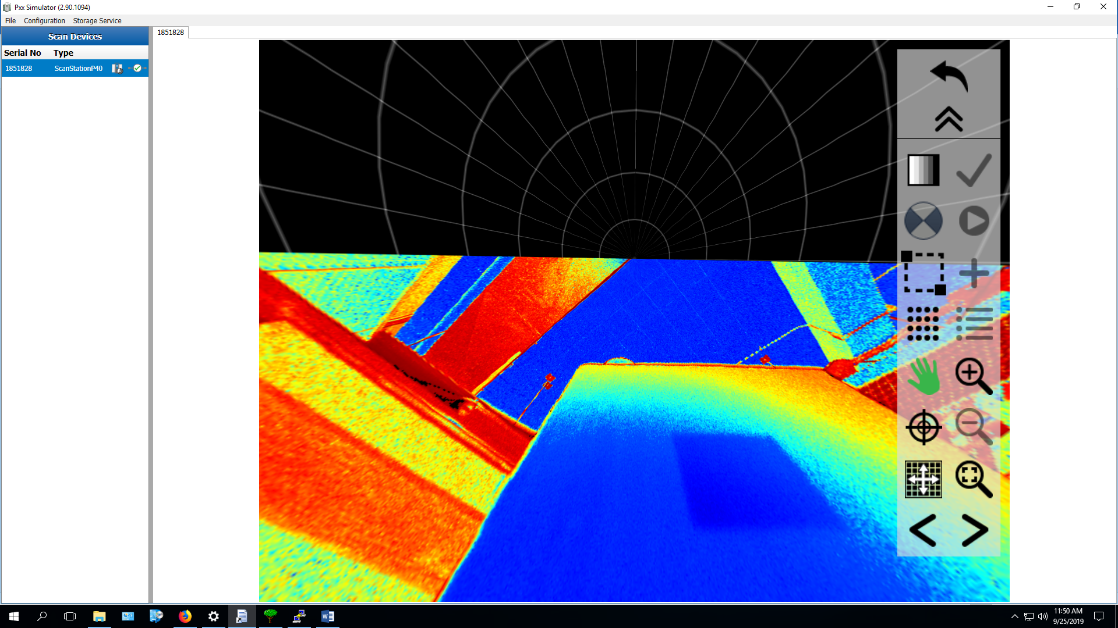

**Scan 2**

0 0 270 180

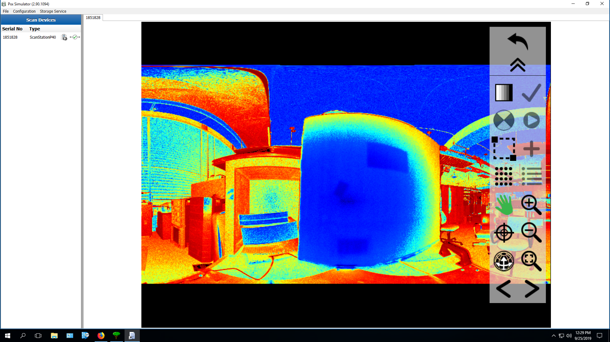

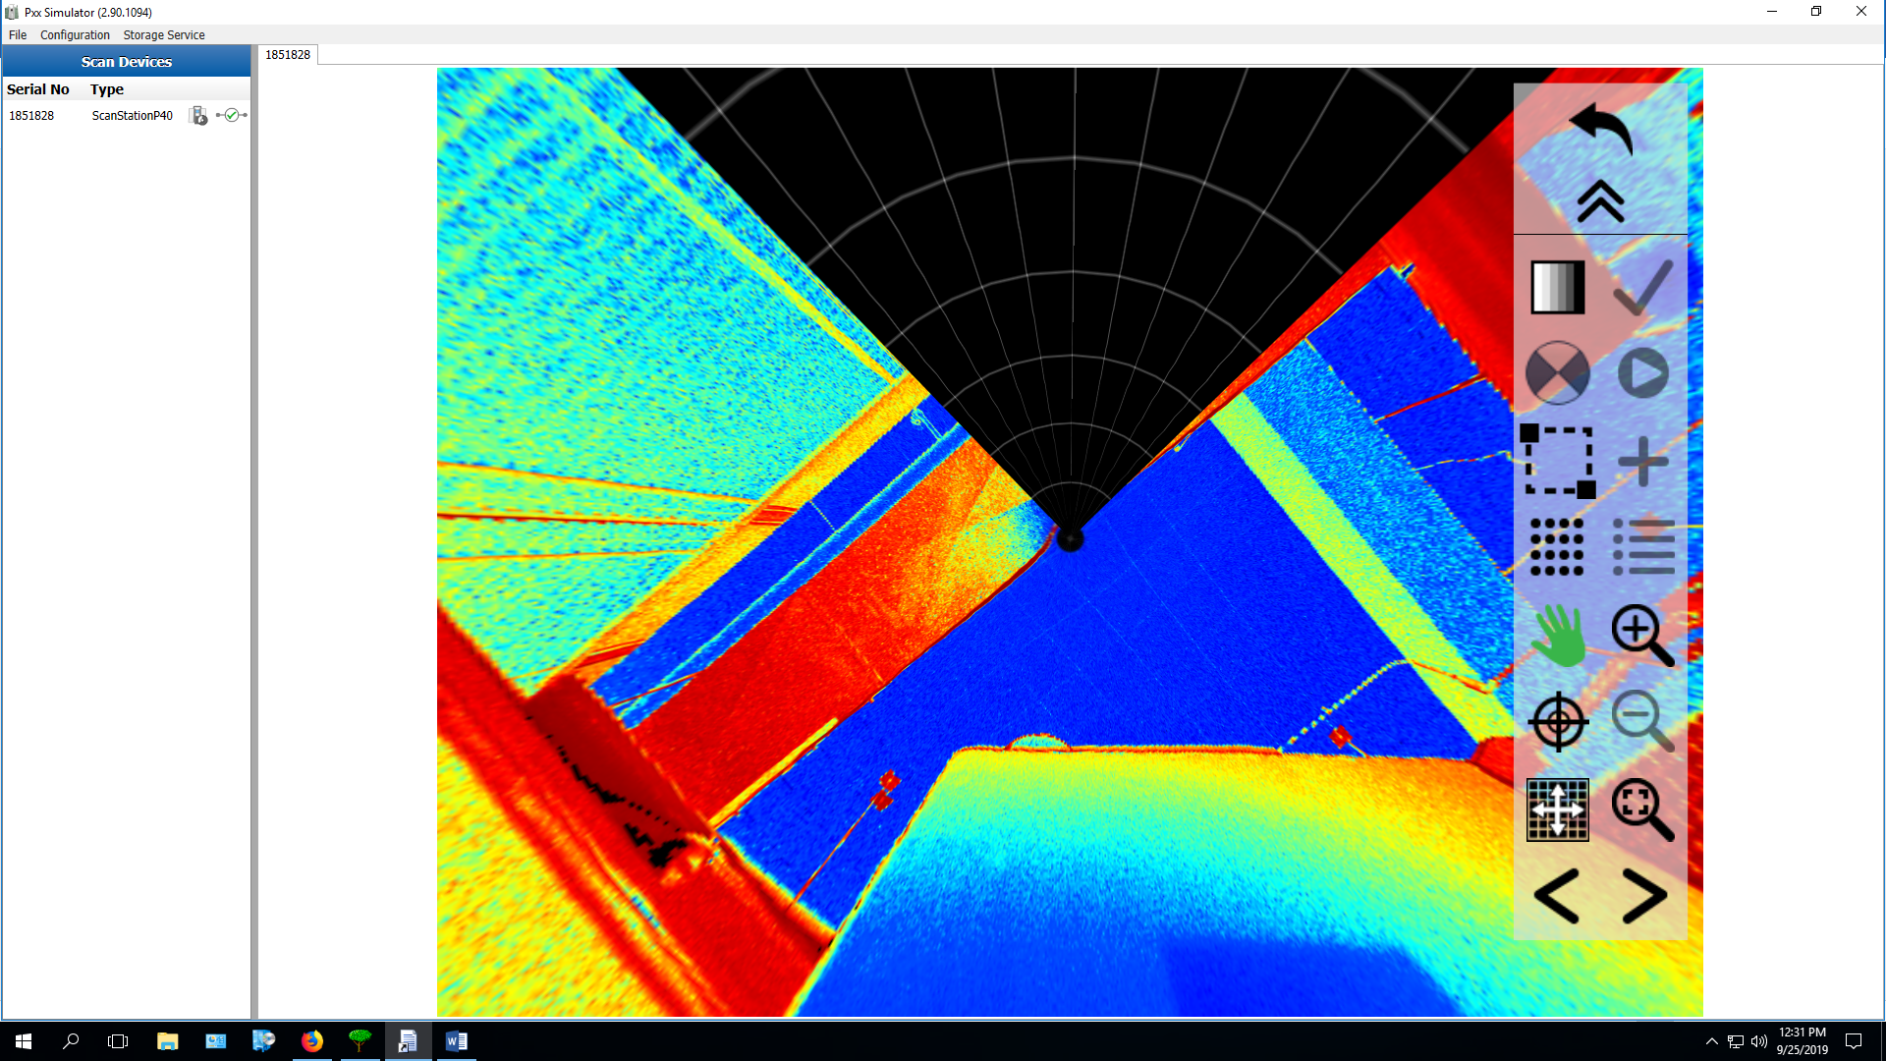

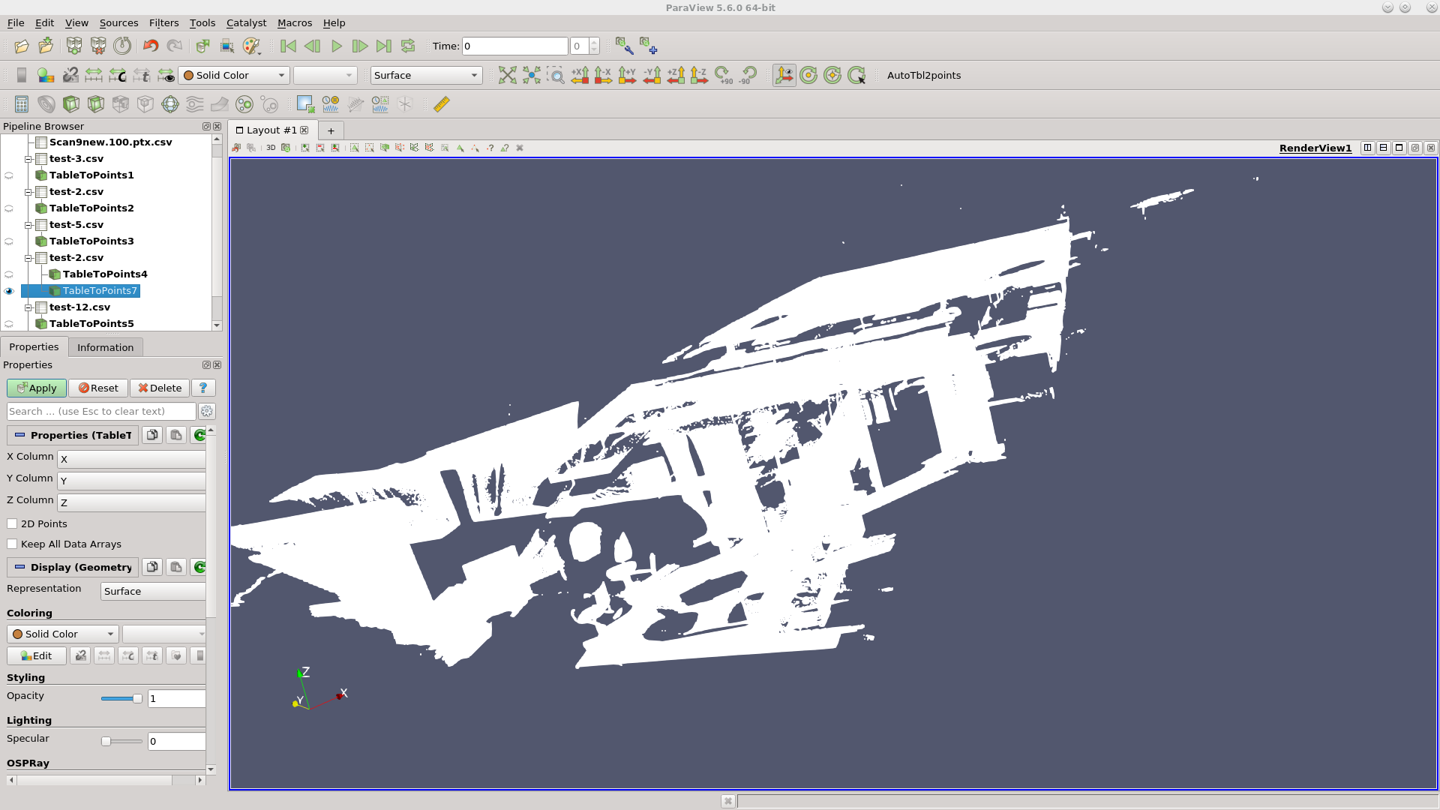

One can just about make out the chairs and our big board on the desk in this image.

**Scan 18**

0 0 360 360

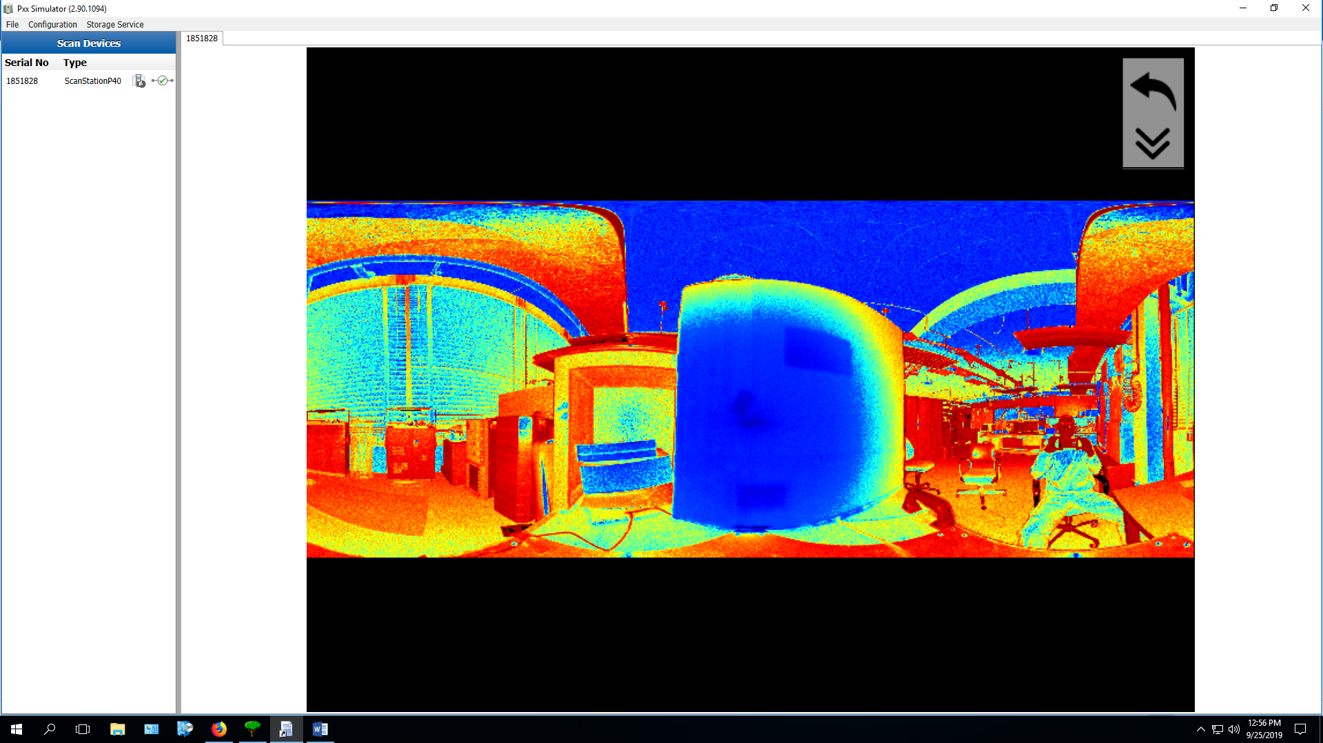

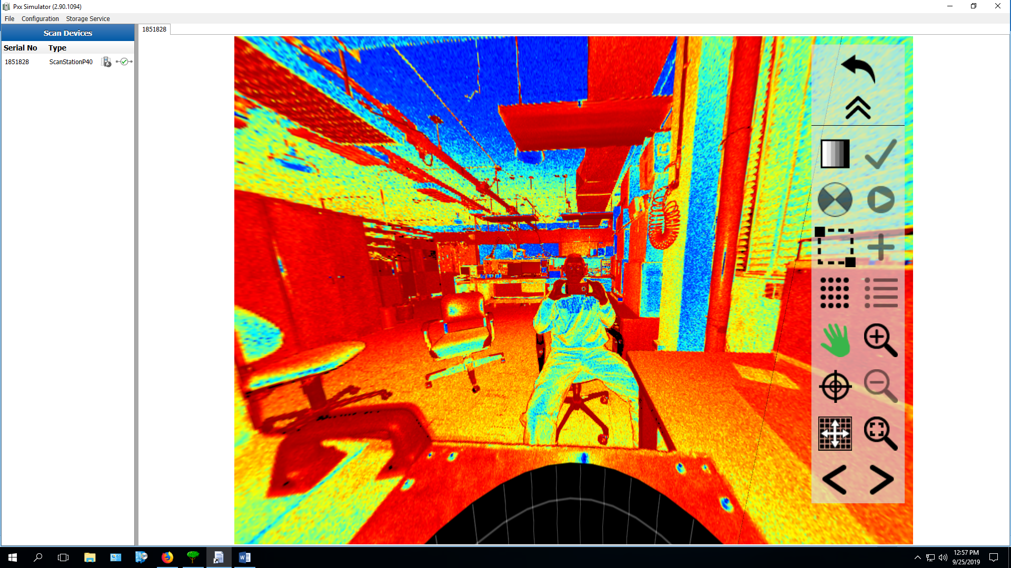

**Scan 19**

0 0 90 90

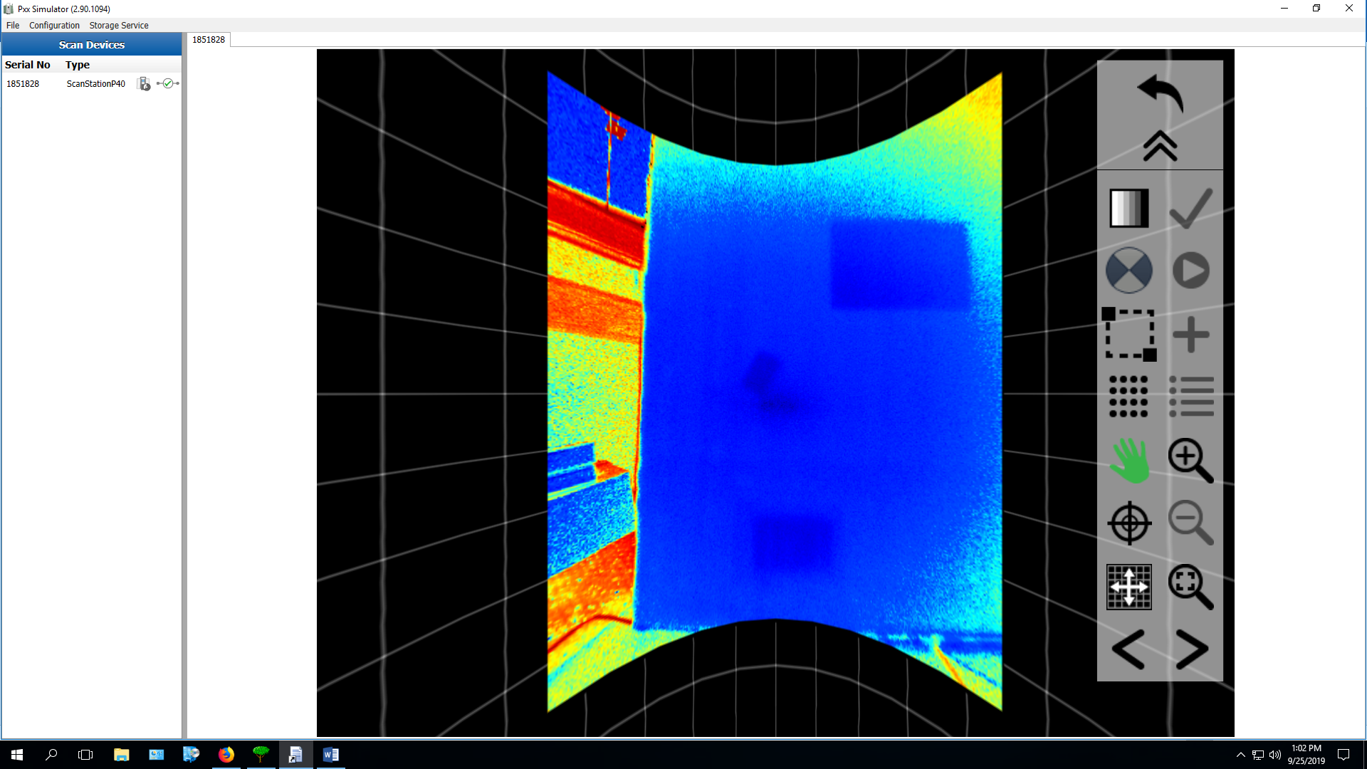

**Scan 20**

0 45 90 90

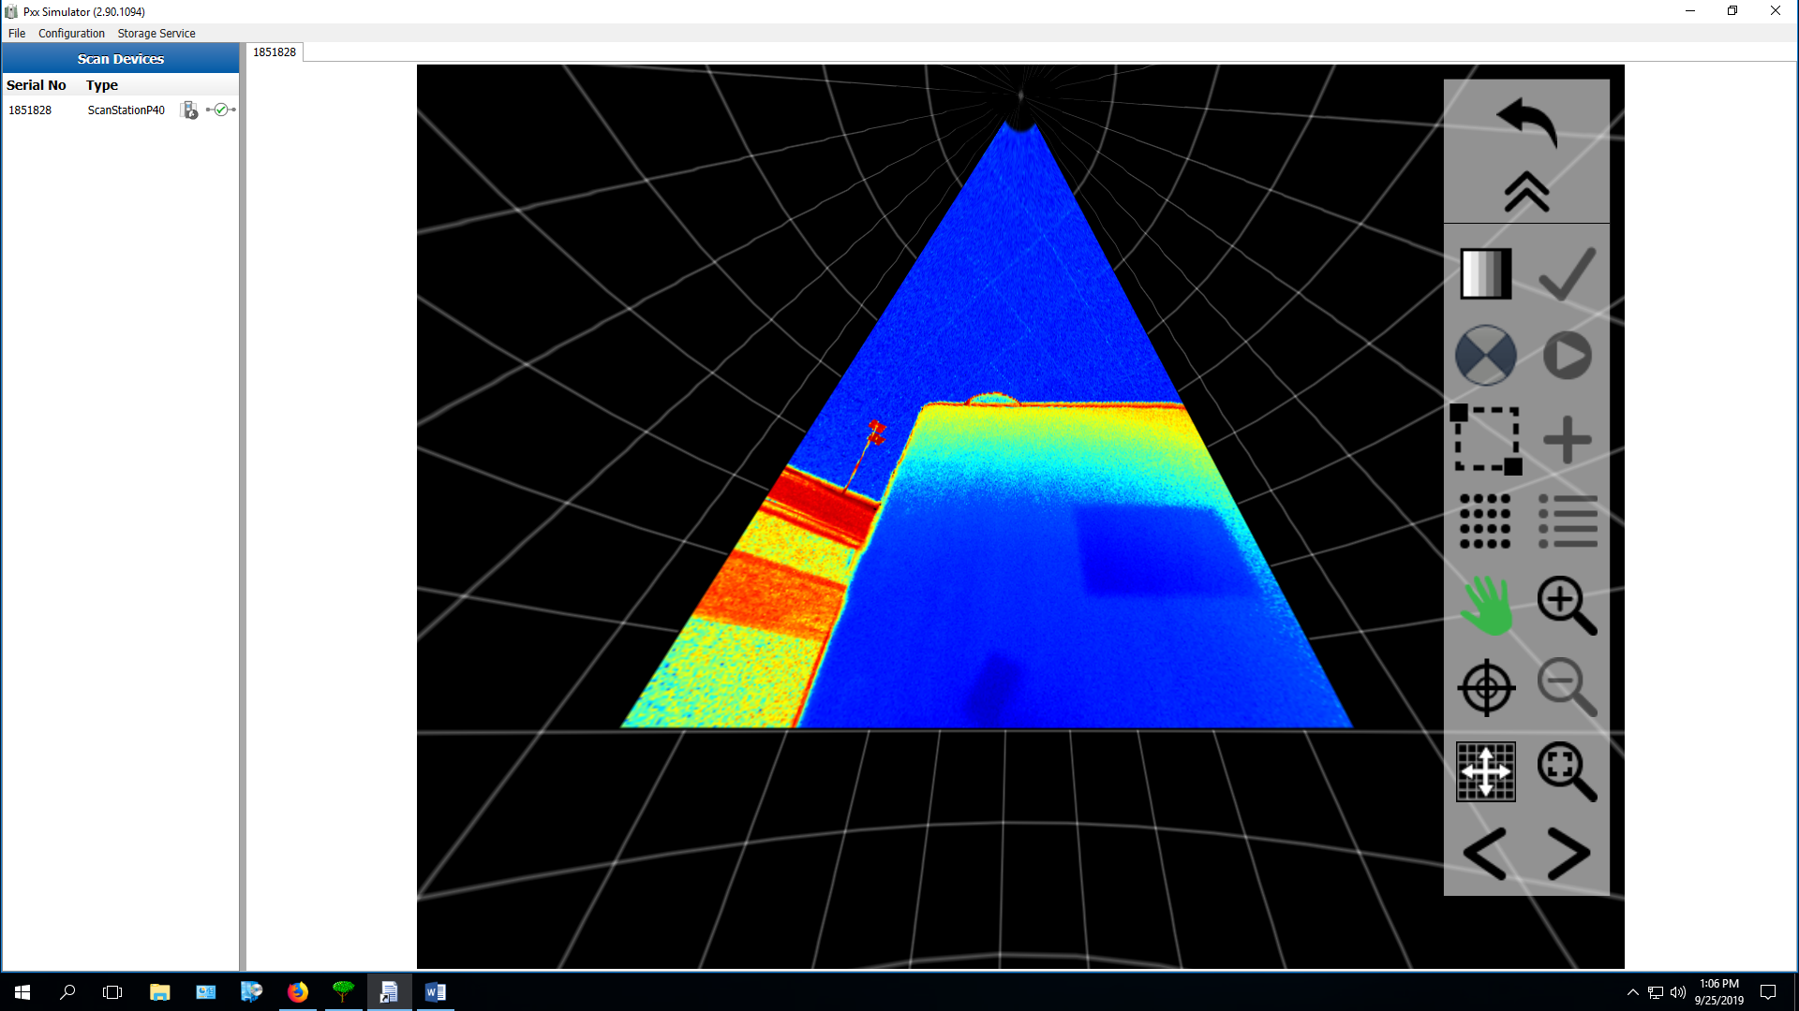

Scan 21

90 0 90 180

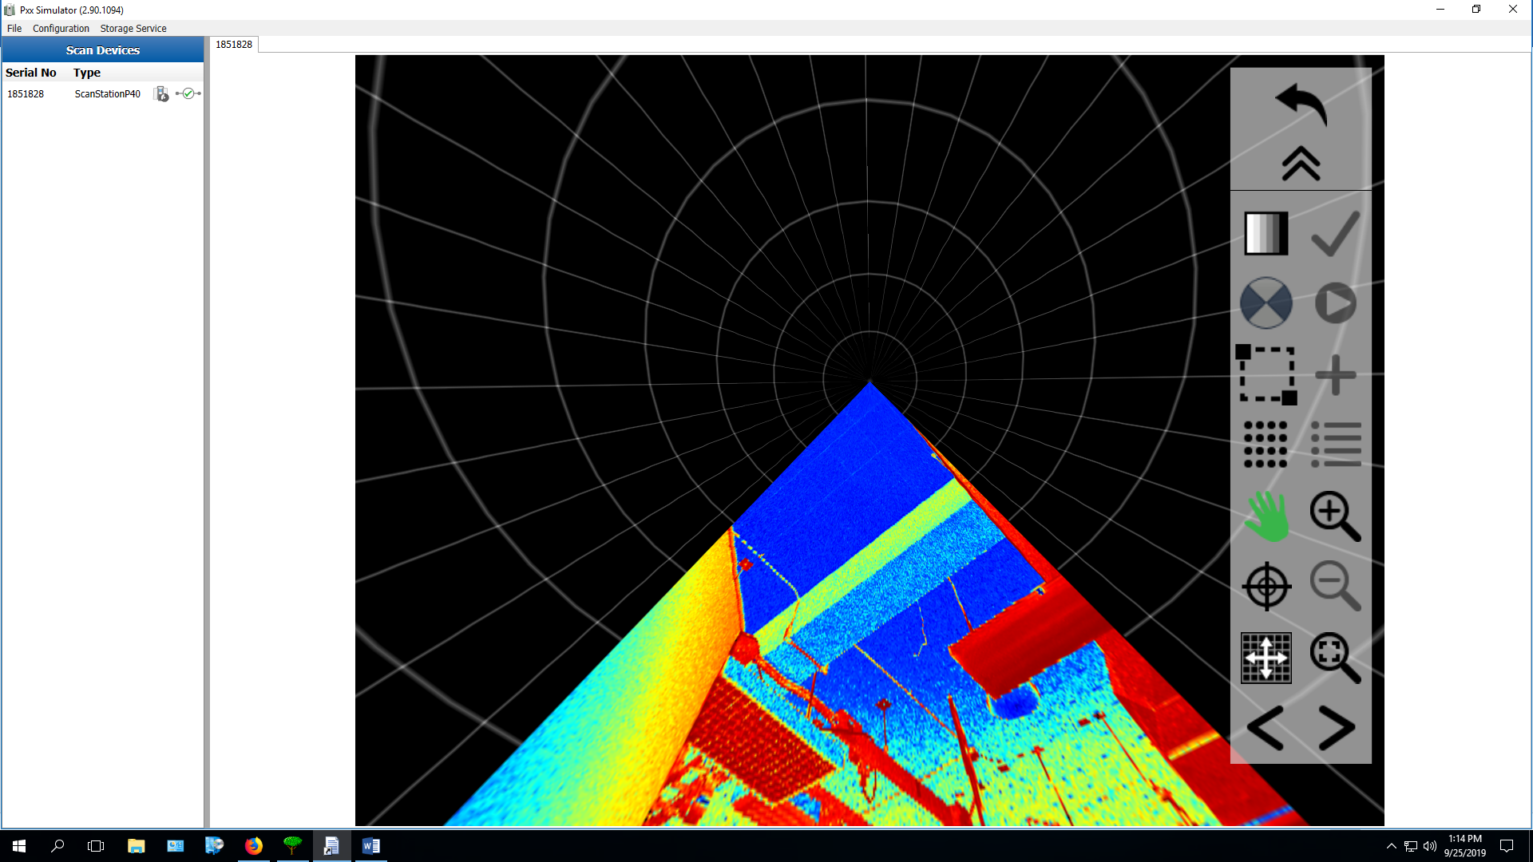

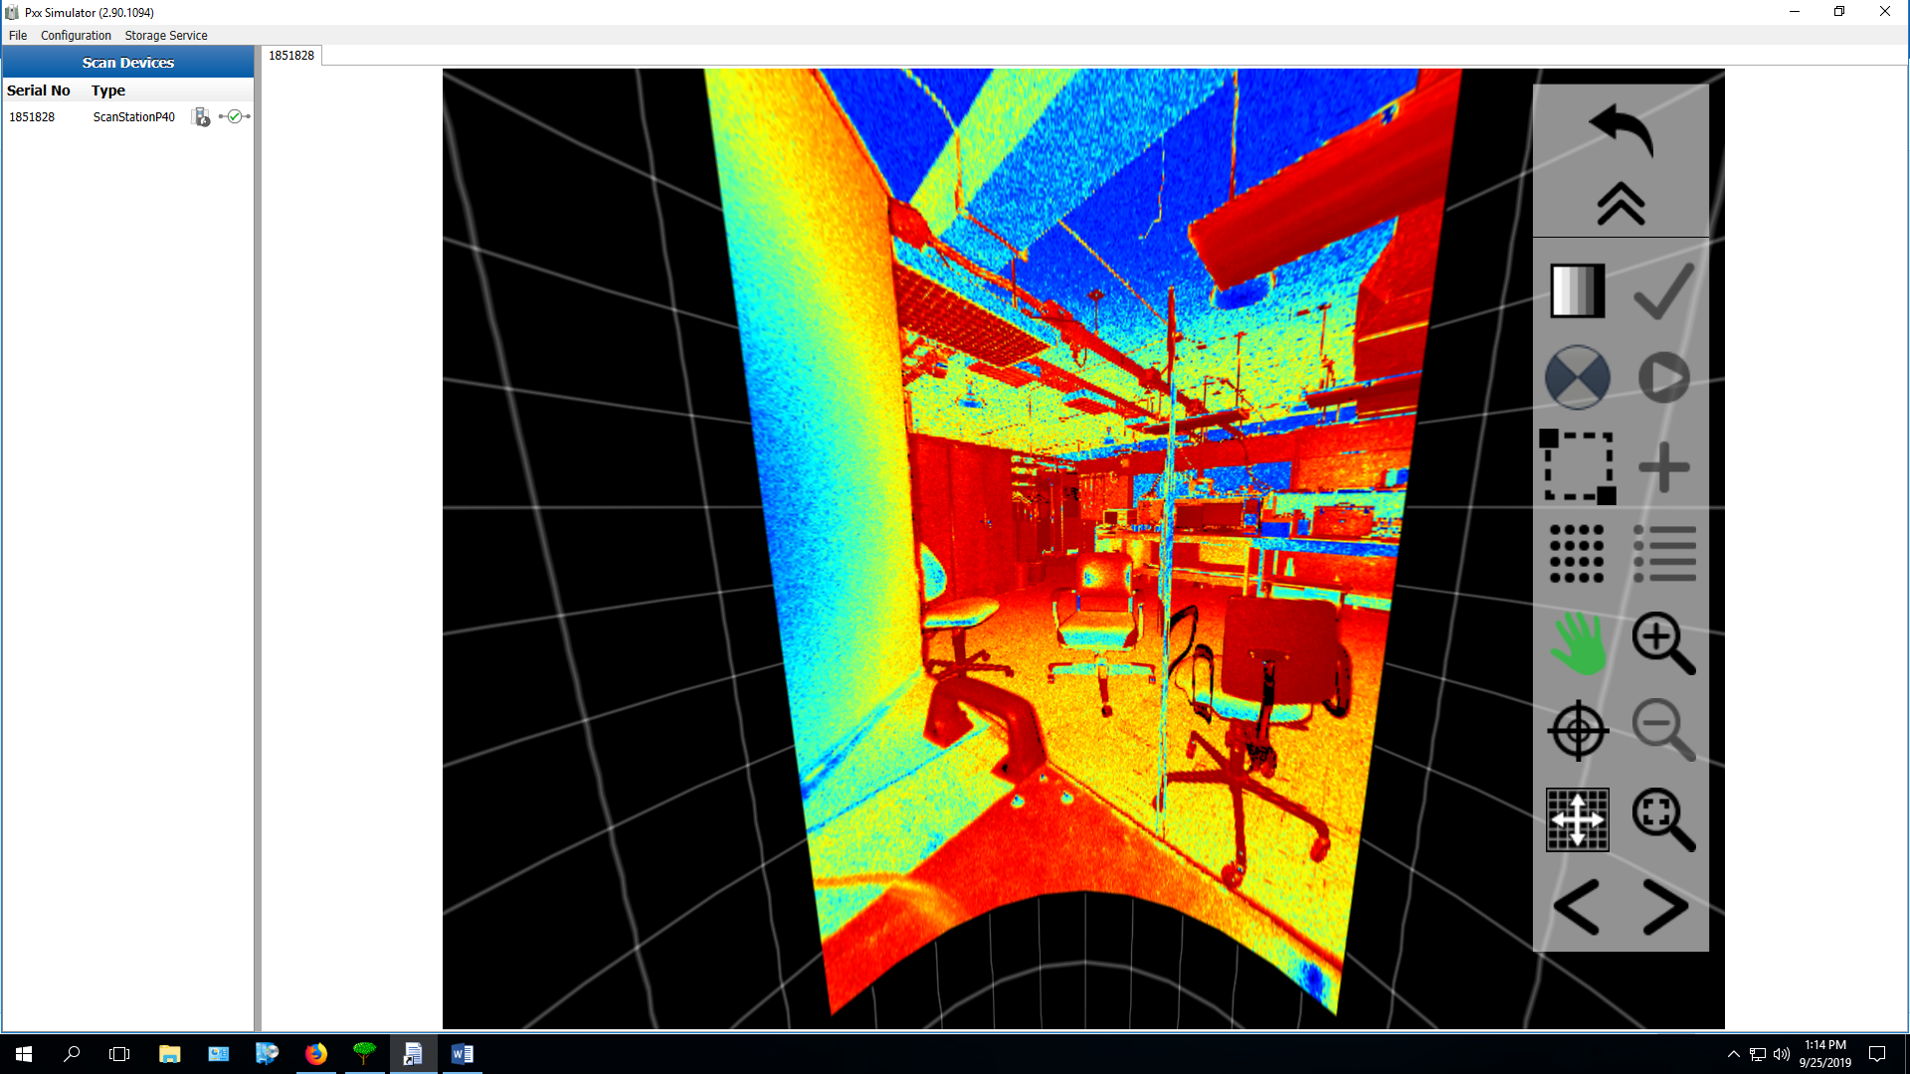

**Scan 22**

180 0 90 180

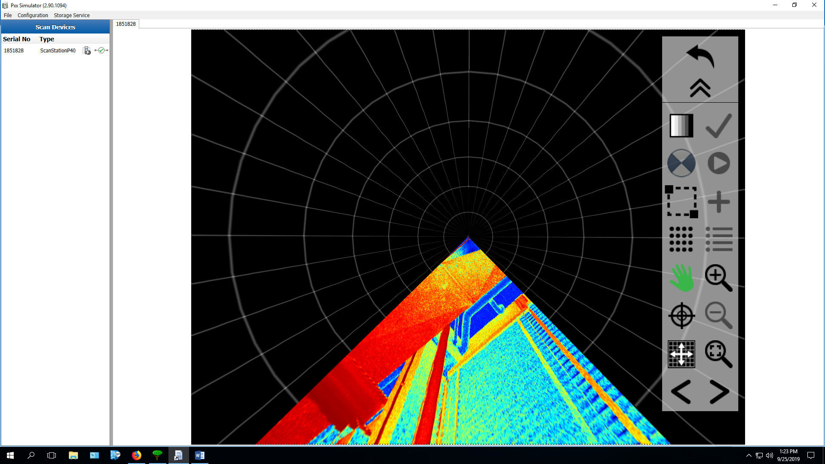

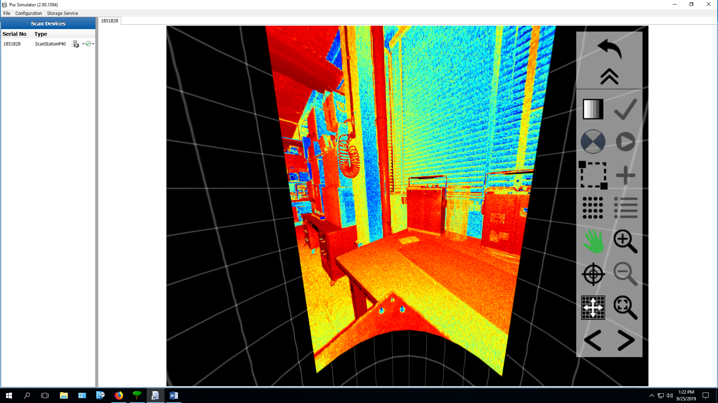

**Scan 23**

270 0 90 180

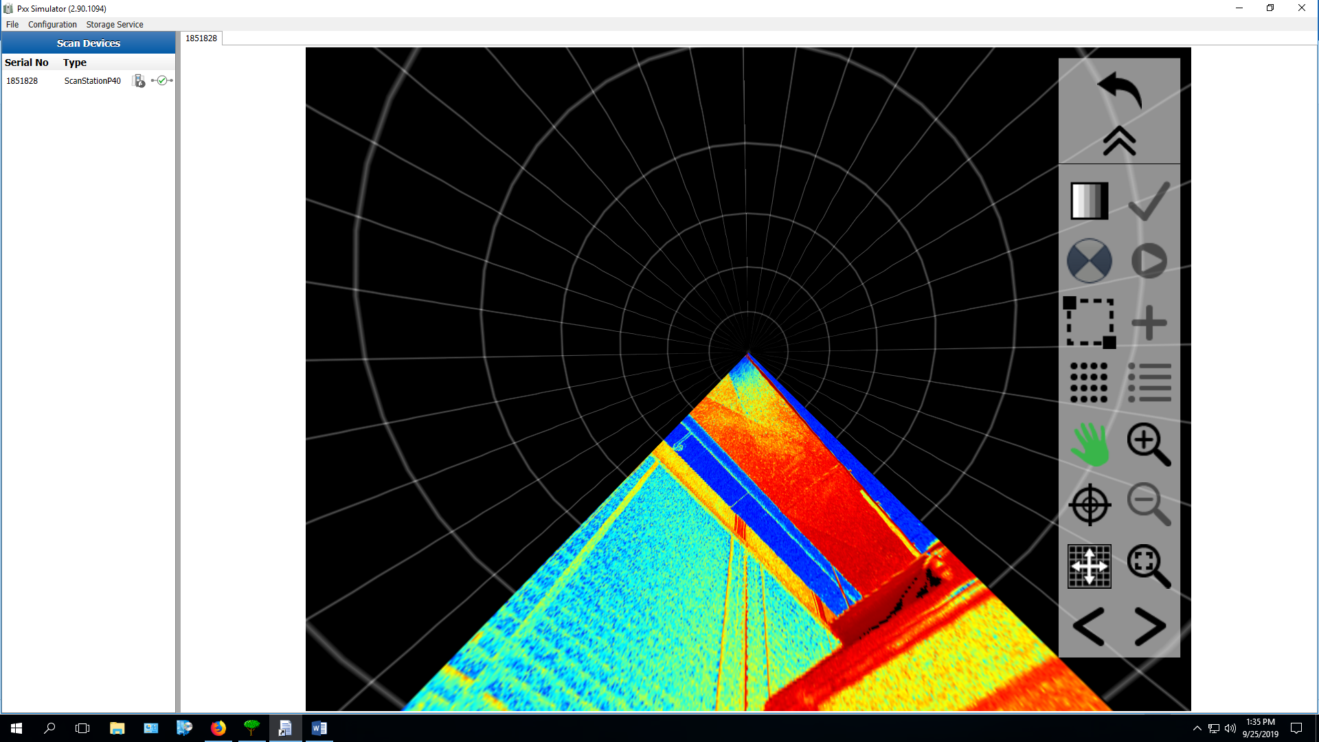

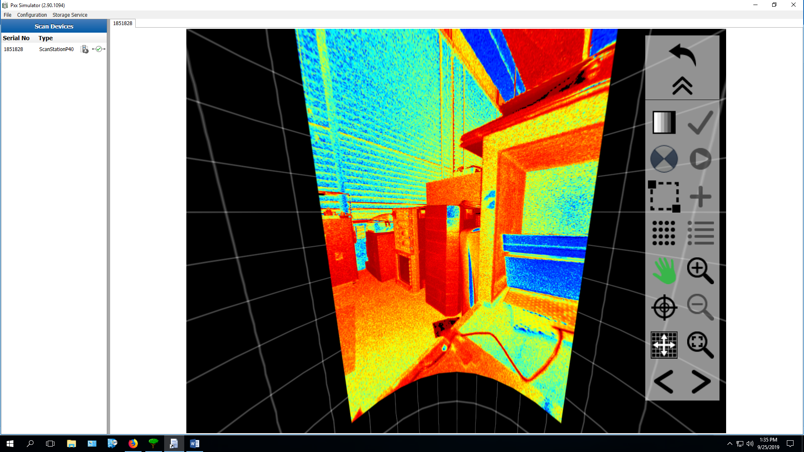

**Scan 24 Portrait**

90 0 90 90



**Conclusions**

The ‘zero’ markings on the scanner line up when commanding the scanner to an azimuth of zero. However, an azimuth of zero is facing in this direction through the scanner, not away from it:

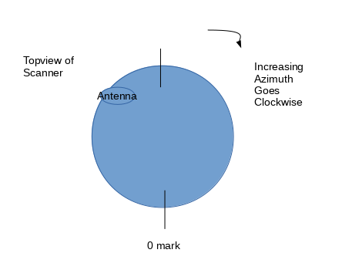

The scanner, when viewed from above, rotates clockwise in increasing azimuth. Here’s how the azimuth space is divided between our scans that broke up the 360 view into 4 90 degree scans:

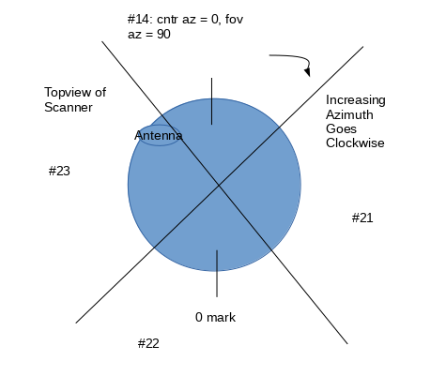

Once we start taking scans larger then 180 degrees in azimuth, the behavior with the second mirror kicks in. See how scan #2, which has an fov az of 270 degrees does not move 270 degrees. Instead it only needs to move 180 degrees to cover this.

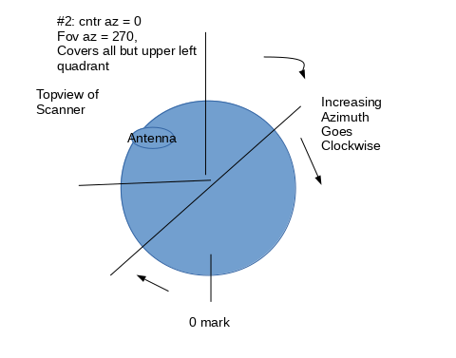

We see something similar with 18 covering the full 360 degrees:

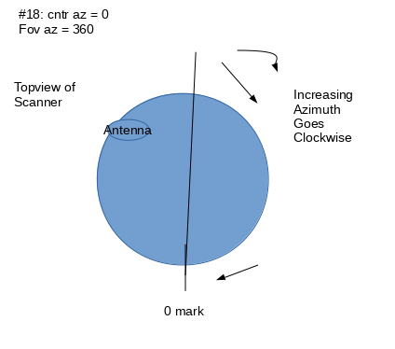

**TBF: conclusions about data size and data export times**

**Appendix A: How to get the color images from the scanner itself**

* open PxxSimulator on Windows Desktop
* Click ‘Scanning’
* Choose the project you set via the input (ex: ‘testScanRange’)
* Click ‘Cont’
* Click ‘VwSc’ (short for ‘view scan’?)
* After a new scan is completed via our API, you must then use the back arrow in the upper right to get back to the project screen, then tunnel down again to view the newest scan.

**Appendix B: how to use paraview**

Ask Joe.